Computational Project - MM209

Predominance Area Diagram for the Ni-S-O system



Department of Metallurgical Engineering and Materials Science INDIAN INSTITUTE OF TECHNOLOGY BOMBAY

*(November 2021)*

Team Members: (Group 12)

Gauri Baheti (200110040)

Kartik Laddha (200110054)

Mrinal Sahu (200110070)

Problem Statement [P4]:

Write a program which gives predominance diagram for Ni-S-O system. Please see the literature for details. The user will input the temperature.

Acknowledgement:

We would like to express our immense gratitude and thank **Professor Nurni N Viswanathan, Professor Aswani Yella and all the Teaching Assistants** for their extraordinary support in this course and in the accomplishment of this project successfully.

Introduction to Predominance Area Diagram (PAD):

Roasting is a gas/solid reaction in which sulphide is converted to oxide or sulphate or even to metal. Whether the roast product is oxide or sulphate or partially sulphide, it would depend on the temperature and partial pressures.

Gibbs phase rule is **P+F = C+2**, where

*P is the number of phases*

*C is the minimum number of chemical components constituting all the phases in the system*

*F is the number of degrees of freedom in the system*

The integer in the Gibbs phase rule is related to the number of intensive parameters such as temperature and pressure that are being considered.

In roasting we have 3 components, that is metal (here nickel), sulphur, and oxygen. Also, pressure has no effect on condensed phases. Mostly roasting is carried out at a constant pressure. The phase rule as applied to a 3- component system at constant temperature and pressure then reduces to **F=3-P.**

For a given temperature the composition of the gas mixture is defined by the partial pressure of gaseous components, pO2 and pSO2. Thus the phase relations in the ternary system as constant temperature may be described in a two-dimensional diagram where pO2 and pSO2 are the two coordinates. Such a diagram is called a **predominance diagram**.

Methodology/Principle:

The predominance area diagram can be constructed easily by writing the standard **Gibb’s free energy** **(∆G°)** values for each of the reactions for the Ni-S-O system.

**∆G° = ∆H° - T∆S° = ∑iui*∆G°f,i(product) - ∑ivi*∆G°f,i(reactants)**

[where u and v are stoichiometric coefficients of products and reactants respectively]

**∆G° = -RT lnK** [where K is the equilibrium constant]

**K = Activity of Products / Activity of Reactants**

*Note: Activity of pure solids is taken as 1 and activity of gases is taken in terms of partial pressures.*

Explanations and Equations in constructing the PAD:

Following diagram depicts the Predominance diagram for Ni-S-O system at constant temperature.

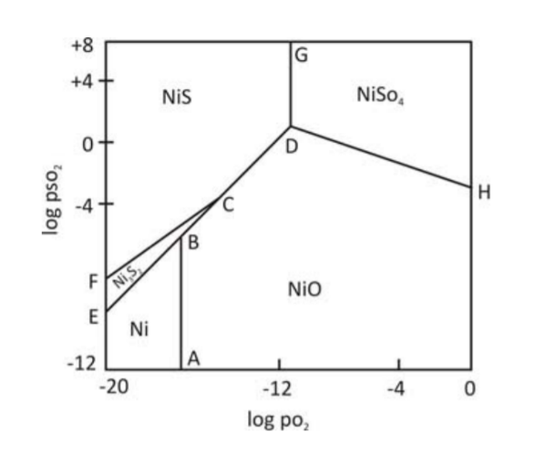

The predominance area diagram depends on both the system and temperature but while making a 2-D diagram we tend to make the graph at a constant temperature.

The equilibrium reactions involved in constructing the diagram are as follows:

1. Equilibrium shown by line AB

Ni(s) + 0.5 O2(g) = NiO(s)

K1 = 1/(pO2) 0.5

**log(pO2) = -2*log(K1)**

∆G1° = -239743.2 - 37.99072*T - 0.5*(-T*205.028552) - (-T*29.87376)

We see that the equilibrium is independent of pSO2 and hence we get a vertical line AB.

1. Equilibrium shown by line DG

NiS(s) + 2O2(g) = NiSO4(s)

K2 = 1/(pO2) 0.5

**log(pO2) = -0.5*log (K2)**

∆G2° = -872907.92 - 97.07*T - (-82006.4 - T*52.96944) - 2*(-T*205.028552)

Hence the line DG is also vertical.

1. Equilibrium shown by line DH

NiO(s) + SO2(g) + 0.5O2(g) = NiSO4(s)

K3 = 1/(pO2)(pSO2)2

**log(pSO2) = -0.5*log(pO2) - log(K3)**

∆G3° = -872907.92 - 97.07*T - (-239743.2 - 37.99072*T) - (-296829.696-T*248.1112) - 0.5*(-T*205.028552)

Now the equilibrium between NiO and NiSO4 is attained by varying the values of pO2 and pSO2. The line DH shows variation between these values.

1. Equilibrium shown by line BC

Ni3S2(s) + 3.5O2(g) = 3NiO(s) + 2SO2(g)

K4 = (pSO2 )2 / (pO2)3.5

**log(pSO2) = 1.75*log(pO2) + 0.5*log(K4)**

∆G4° = 3*(-239743.2 - 37.99072*T) + 2*(-296829.696 - T*248.1112) - (-202924 - T*133.888) - 3.5*(-T*205.028552)

Hence line BC depicts the variation between log(pSO2) and log(pO2) for given equilibrium.

1. Equilibrium shown by line CF

Ni3S2(s) + SO2(g) = 3NiS(s) + O2(g)

K5 = (pO2 ) / (pSO2)

**log(pSO2) = log(pO2) - log(K5)**

∆G5° = 3*(-82006.4 - T*52.96944) + (-T*205.028552) - (-202924 - T*133.888) - (-296829.696 - T*248.1112)

Hence line CF depicts the variation between log(pSO2) and log(pO2) for given equilibrium.

1. Equilibrium shown by line CD

NiS(s) + 1.5O2(g) = NiO(s) + SO2(g)

K6 = (pSO2) / (pO2)1.5

**log(pSO2) = 1.5*log(pO2) + log(K6)**

∆G6° = -239743.2 - 37.99072*T - 296829.696 - T*248.1112 – (-82006.4 - T*52.96944) - 1.5*(-T*205.028552)

Hence line CD depicts the variation between log(pSO2) and log(pO2) for given equilibrium.

1. Equilibrium shown by line EB

3Ni(s) + 2SO2(g) = Ni3S2(s) + 2O2(g)

K7 = (pO2 )2 / (pSO2)2

**log(pSO2) = log(pO2) – 0.5*log(K7)**

∆G7° = -202924 - T*133.888 + 2*(-T*205.028552) - 3*(-T*29.87376) –

2*(-296829.696 - T*248.1112)

Hence line EB depicts the variation between log(pSO2) and log(pO2) for given equilibrium.

Plot Results:

Following diagram depicts the PAD made with Python:

1. T = 300 K

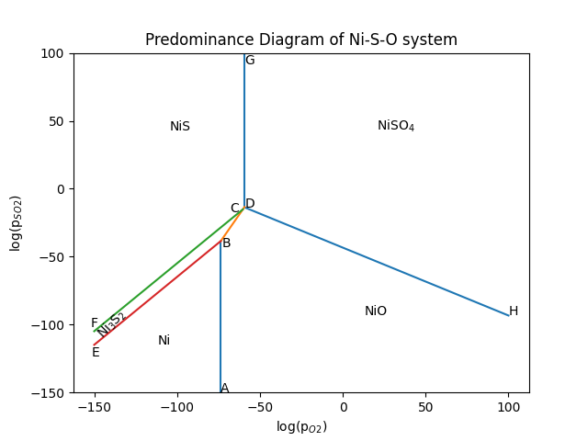

At points B, C and D, three condensed phases are at equilibrium for a particular value of pSO2 and pO2. F=0 at these points, e.g. At point C NiO/NiS/Ni3S2 can co-exist at a constant pO2 and pSO2.

At point B NiO/Ni/Ni3S2 can co-exist at a constant pO2 and pSO2.

At point D NiO/NiS/NiSO4 can co-exist at a constant pO2 and pSO2. Hence these are called **Invariant points**.

The lines describe the equilibrium between any two condensed phases. Along the lines, degree of freedom F=1 hence we can vary either pO2 or pSO2 to obtain phase on either side of the line.

For example, line BC shows equilibrium between Ni3S2/NiO.

Line DH shows equilibrium between NiO/NiSO4.

Line FC shows equilibrium between NiS/Ni3S2.

Line EB shows equilibrium between Ni/Ni3S2.

Line CD shows equilibrium between NiS/NiO.

Similarly other lines show dependence on the partial pressure of O2 and SO2.

Along lines AB and DG there is no dependence of product formation on pSO2 and hence these lines are vertical.

1. T = 500 K

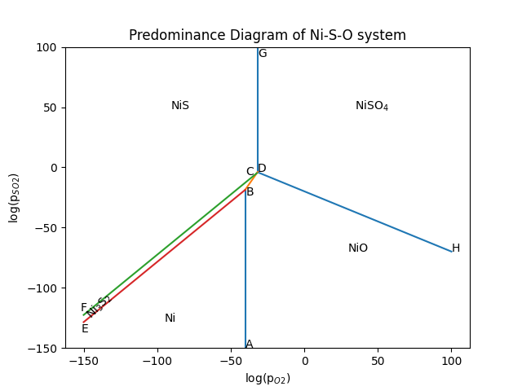

Utility of the CAD:

1. PAD shows the stable phase under different conditions (gas pressures).
2. PAD predicts possible processing routes.

Sources:

* Lecture 15: Thermodynamics of roasting Contents Preamble Phase rule Predominance area diagram Method of construction
* <https://nptel.ac.in/content/storage2/courses/113104060/MHB_pdf/Lecture15.pdf>
* <http://webbook.nist.gov/>
* <https://www.drjez.com/uco/ChemTools/Standard%20Thermodynamic%20Values.pdf>

Team-Mates & Contribution:

The report was prepared and drafted equally by all of us.

Respective Contributions:

* **Gauri Baheti (200110040):** worked out the literature including the equations involved and finding the Gibbs Free energy data for the reactions. Wrote the python code for the CD and DH lines, taking input temperature and importing the libraries.
* **Kartik Laddha (200110054):** wrote the python code for the lines AB and DG and labelling of the axes and the legend.
* **Mrinal Sahu (200110070):** Wrote the python code for initialising the constants and for the lines BC, FC and EB and labelling the points and areas in the diagram. Prepared the entire Readme file for writing the instructions and the additional comments to run the code.

# Thank You!